Engagement

During these months，we have done some activities that involved all parts of people in society to increase people's knowledge about Synthetic Biology, to make iGEM known to more people and to make our project more influential among people of various jobs. In order to achieve the first goal, we took use of the platform of Begonia Festival of our school to hold up a propaganda involving intriguing games. For the second goal, we set up a Lab-Open day which allows high school students, college students and adults to visit our labs and do some easy experiments in person and to take part in the teach-ins held by our team to know more details of iGEM. We also went to TUST to take part in their iGEM promotion activities to increase the popularity of iGEM in their school and to promote the amicable relationships between our team and team of TUST. What's more, we developed a public research involving people across China on the platform of Wechat for the sake of the third goal.

Begonia Festival

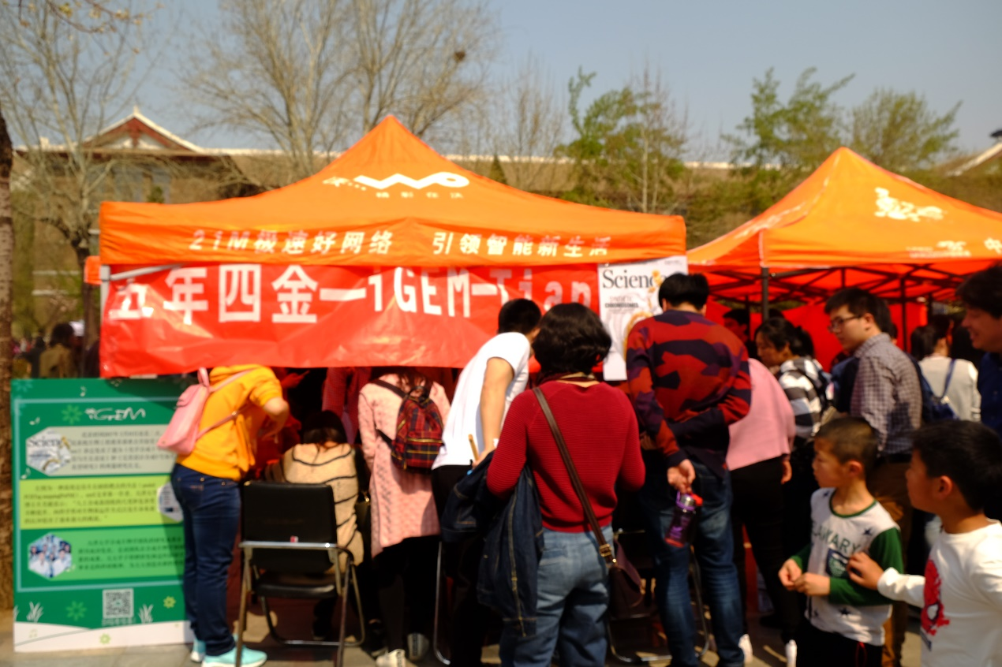 On April 3rd, about thirty thousand people stepped in TianJin University to take part in the Begonia Festival and to enjoy the bueaty of spring. Our team decided to take advantage of this opportunity to make public know more about Synthetic Biology. We let people joining our activities inoculate bacterias in culture medium in any pattern they want, during which they can enjoy the happiness of doing biology experiments and get more interested in biology study.

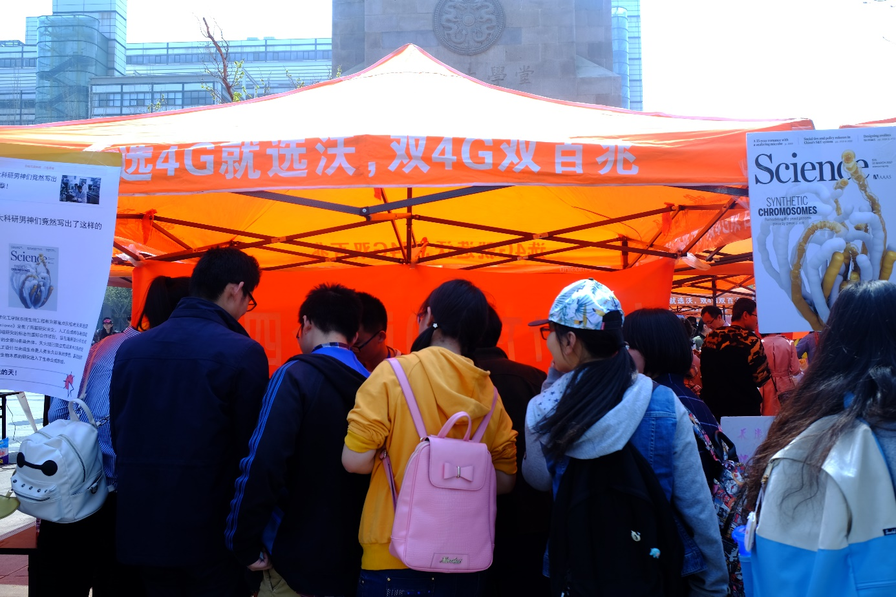

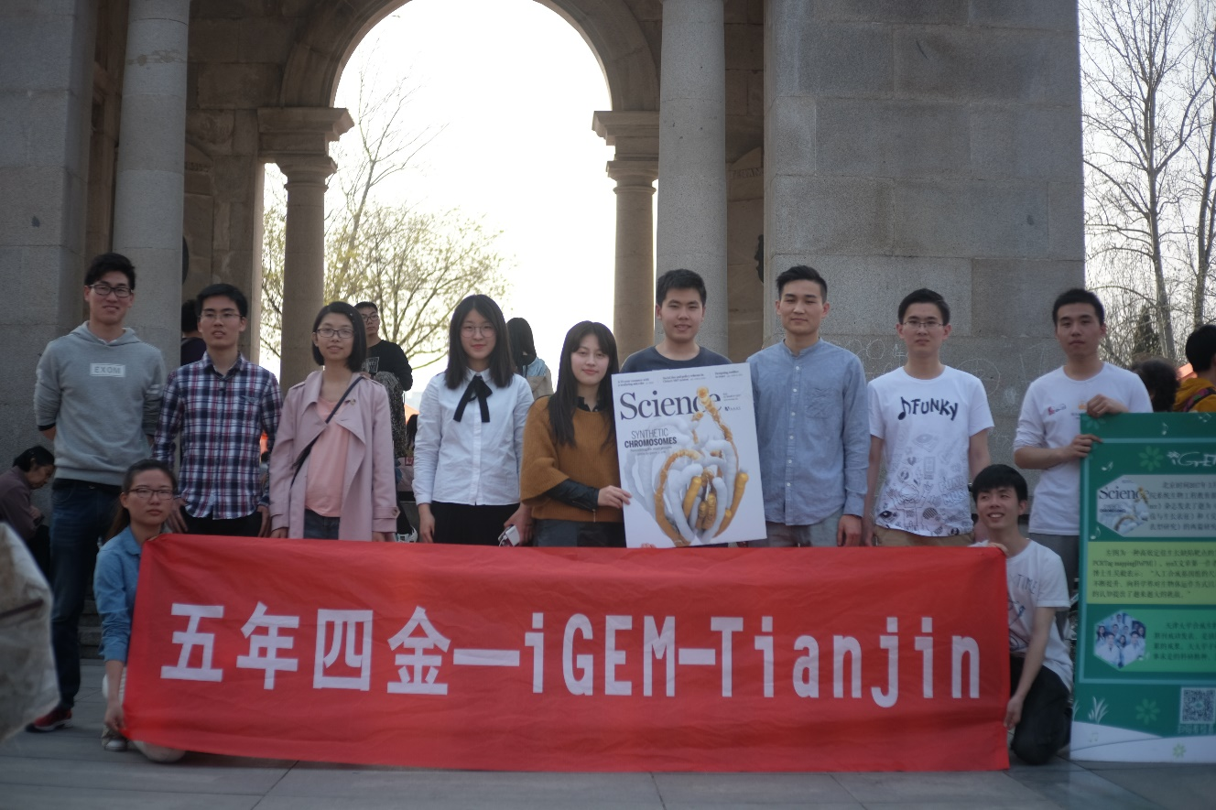

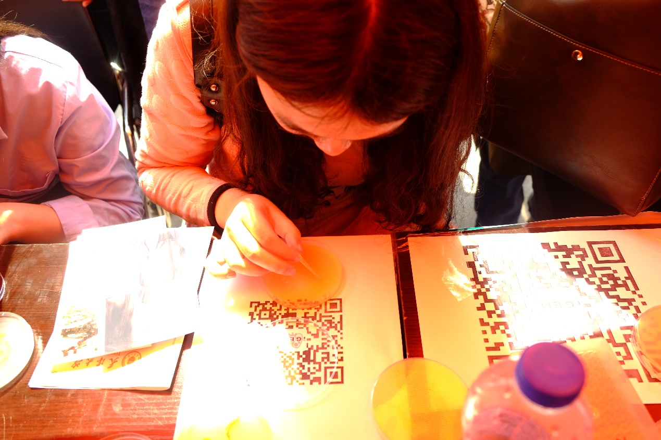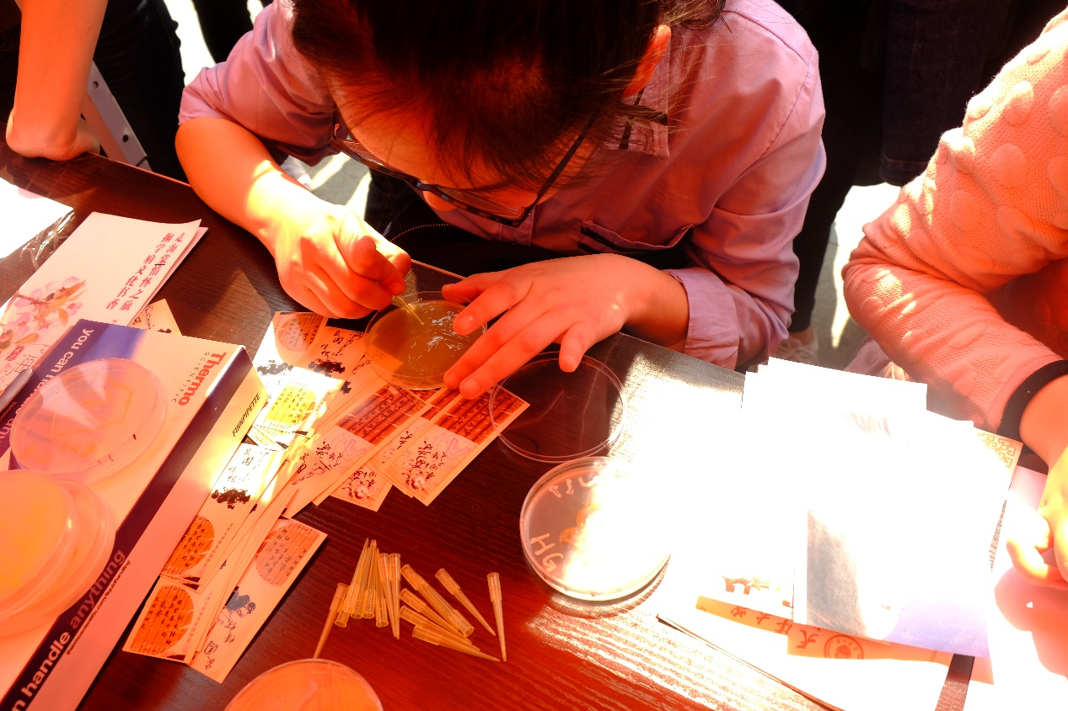

A few days later, when the bacteria they inoculated grew mature, we put these pictures of the pattern bacterias grew onto our Wechat subscription, which received a good feedback among people who joined it.

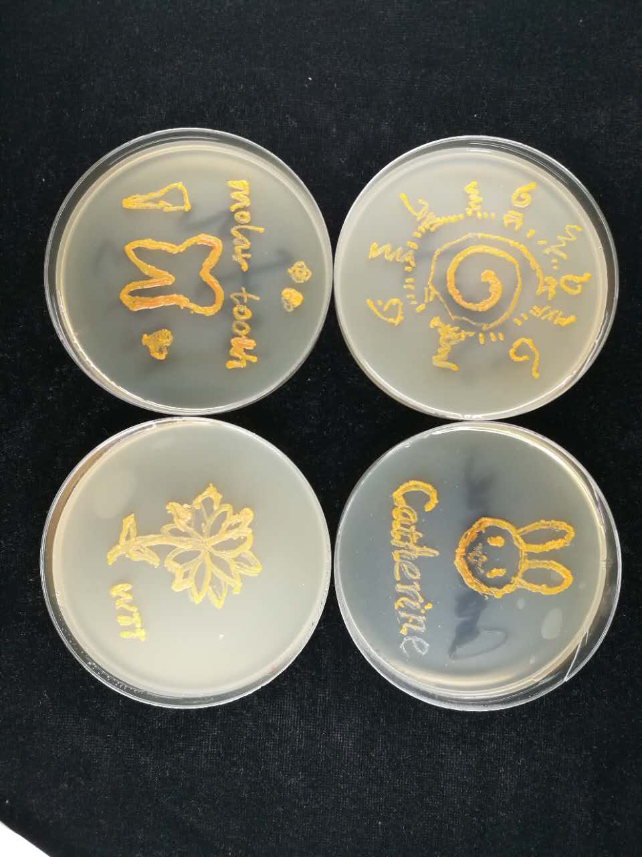

Lab-Open Day

In order to promote the popularity of iGEM and Synthetic Biology among people who are interested in biology. We released the information of this activity in our Wechat subscription and received many entry blanks from high school students, college students and the parents of this high school students. First of all, we held a teach-ins taken part by these students and parents. During the meeting, we talked about what is iGEM, its origin and rules. What is more, we talked about the projects of TianJin iGEM in recent years with easy- to-understand way. In the end of the meeting, there was a question-answer session, which means that we threw out some questions based on the contents of we had talked, the student with the highest score can abstain our special gifts. By this session, we knew that students joined our meeting already had a rough understand of iGEM and Synthetic Biology.

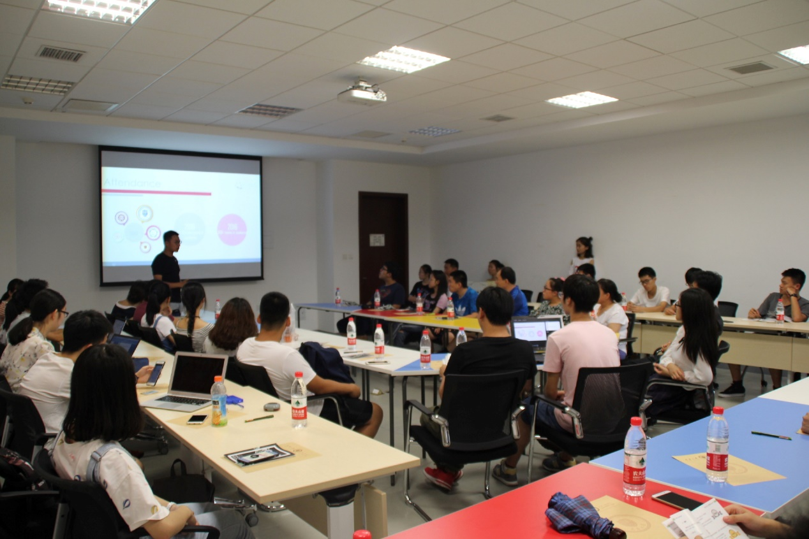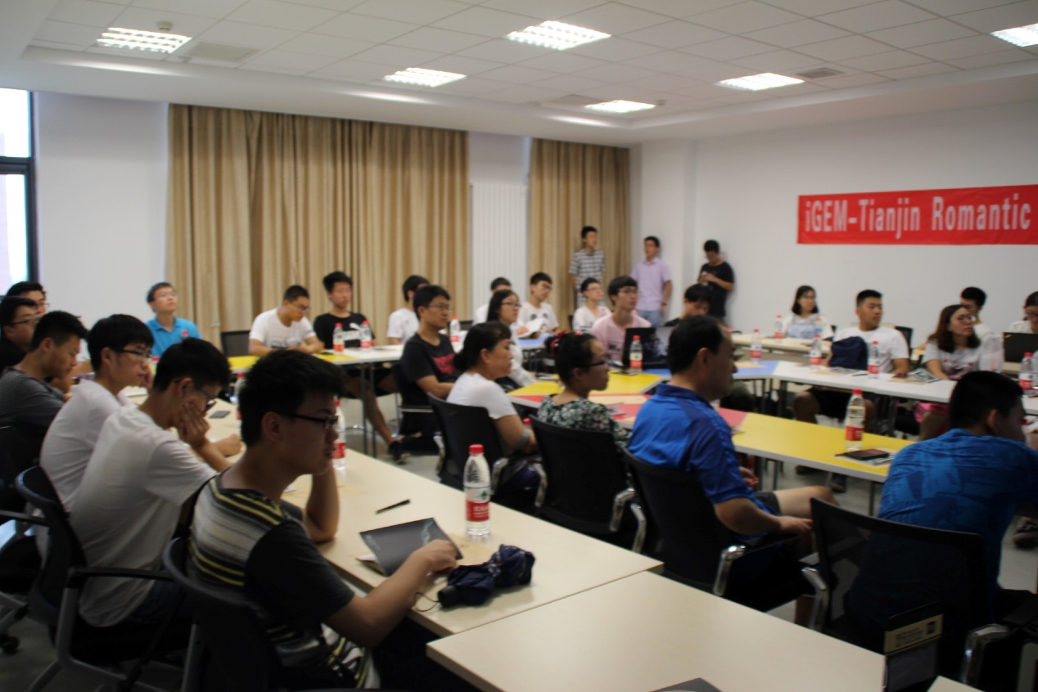

After the meeting, we took them to our labs. We showed them the experimental process of Synthetic Biology such as PCR, inoculate bacterias on the culture medium, centrifugation and extract plasmid. By this visit, both students and parents got a closer understand of biology science and the process of doing scientific research. Because these parents told us that they were concerned about the prospect of doing scientific research and they were afraid of the tedium of science, we gave them some information about our experience during taking part in iGEM, and told them that doing scientific research was not as scary as they imagine.

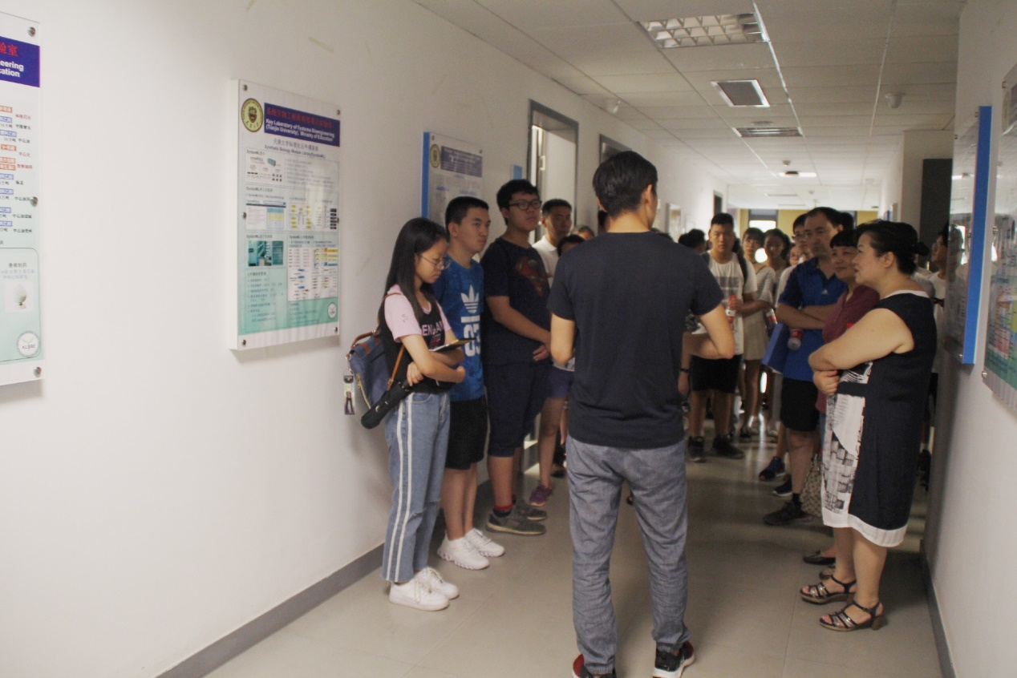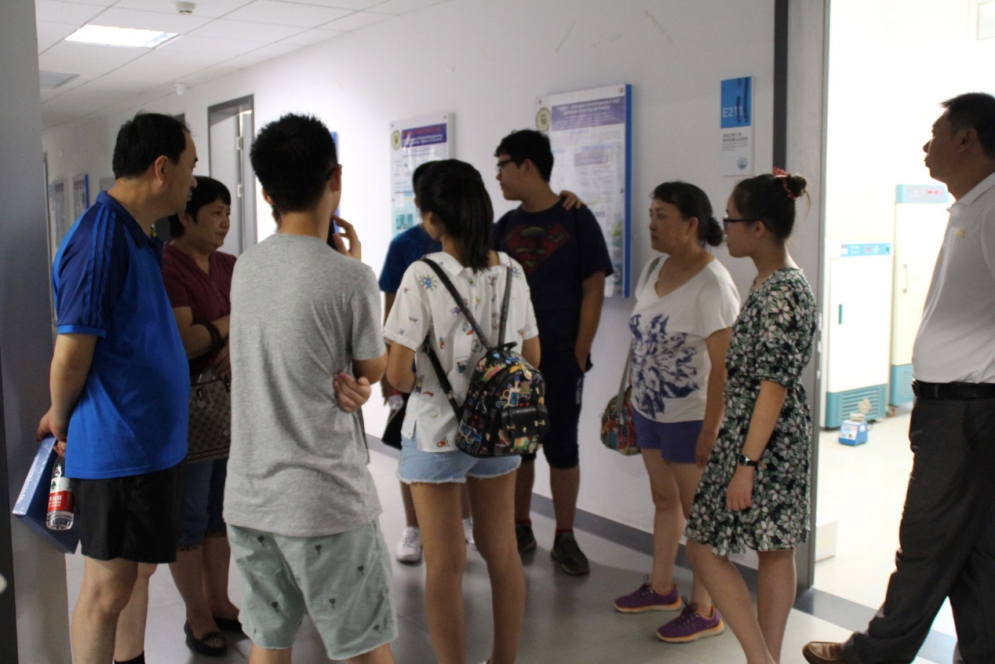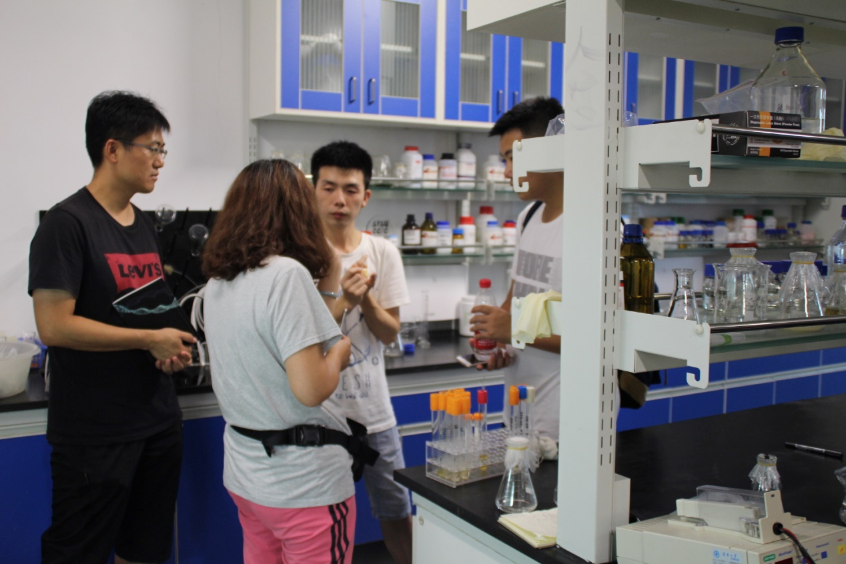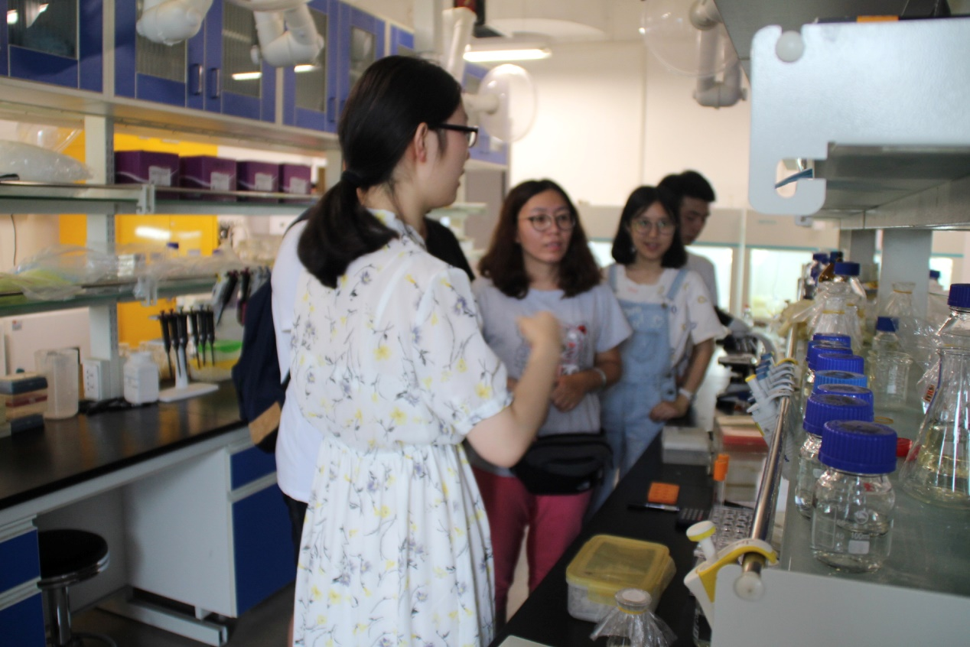

Public Research

In order to know whether people around China know about pollution of heavy mental and make information about this problem known to more people, we developed a public research on the platform of our Wechat subscription. This questionnaire was filled by people in various province of China, and we can get the information that most people have a rough understand of heavy mental pollution but few of them start a research about how is the heavy mental discharged into the environment and how to reduce this pollution. According to the results of the questionnaire, we also knew that people are more willing to use biology method to settle heavy mental down than using chemical or physical method.

Our research had also published on the iGEM official collaboration website. We had received 1000 answers in roll.

Apart from the activities we have done above, we also have a good contact with experts in Synthetic Biology to obtain more neoteric ideas. On March 7th, the founder of SynBioBeta-John Cumbers came to TianJin University to have a talk with our mentor-professor Yingjin Yuan to talk about the development of Synthetic Biology in China and the projects of our team in recent years. This meeting attracted a lot of students to come. John Cumbers listened to the speech of our team leader-Mingzhe Han carefully and he said that it was amazing how big progress our team had made during these years. During the meeting, the investor of FressVC shared with us the broad prospects of Synthetic Biology and he told us that he was hoping us to realize the commercialization of Synthetic Biology and industrialization. In the end of the meeting, the members of our team asked some question about Synthetic Biology such as how does Synthetic Biology as a newly emerging subject realized the promotion across the world and what is the future trend of Synthetic Biology. John Cumber said that iGEM played an important part in the promotion of Synthetic Biology and in the future, Synthetic Biology may create some biological tools like computer to simulate the process of the evolvement of biological species. We learned a lot during this meeting and had a more clear assessment of Synthetic Biology.

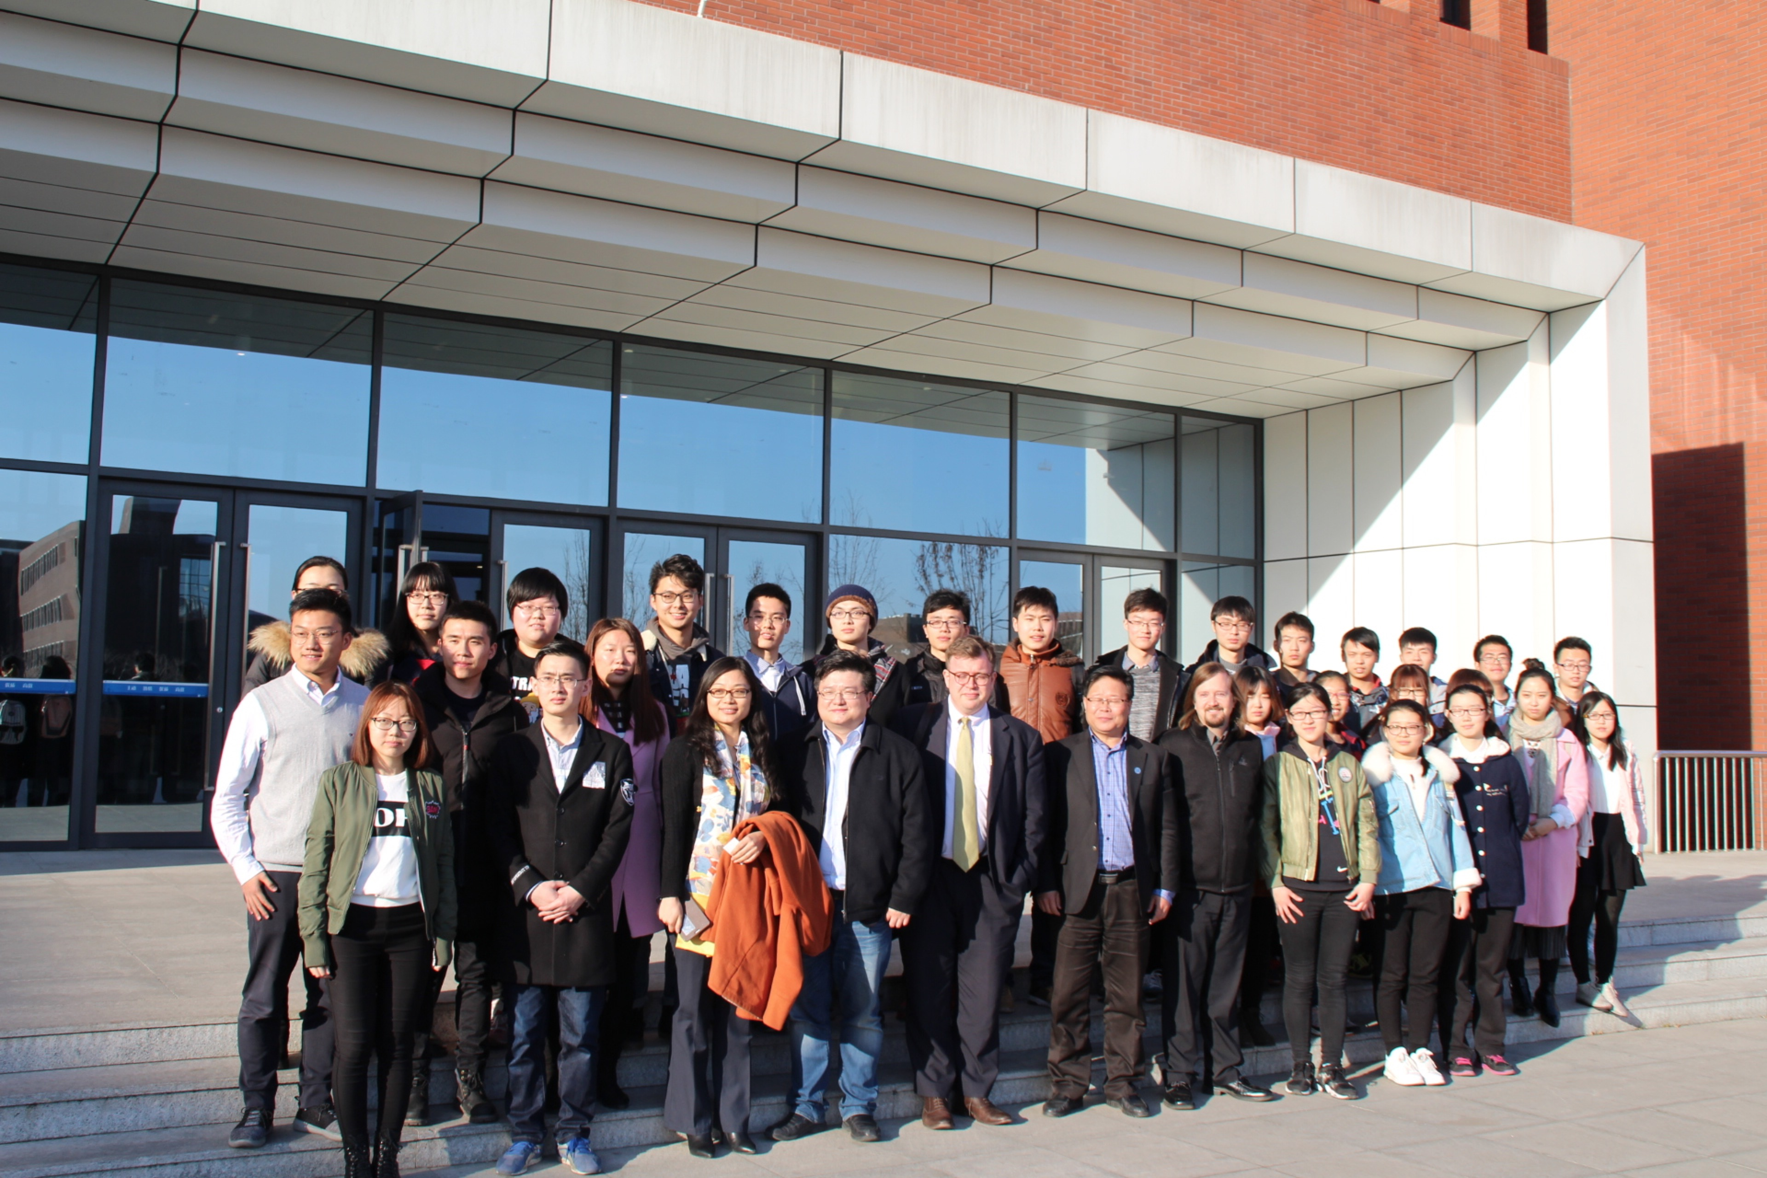

Group photo of our team and John Cumber